AWS Task - 2
Task Description:
Set up a VPC with an Internet gateway, create a public subnet with 256 IP addresses, a private subnet with 256 IP addresses, make a route table connecting the Internet gateway and the subnets, and launch a Linux EC2 instance by using the above VPC and public subnet.

*Created a VPC with the name my-vpc-01 and within the IPv4 CIDR block provided 10.0.0.0/16 as it has /24 subnets.
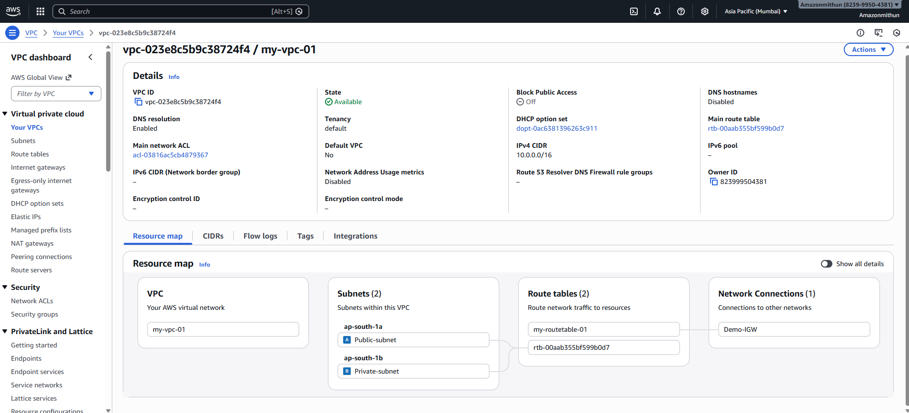
*created a Internet gateway with name Demo-IGW and attached IGW to created VPC
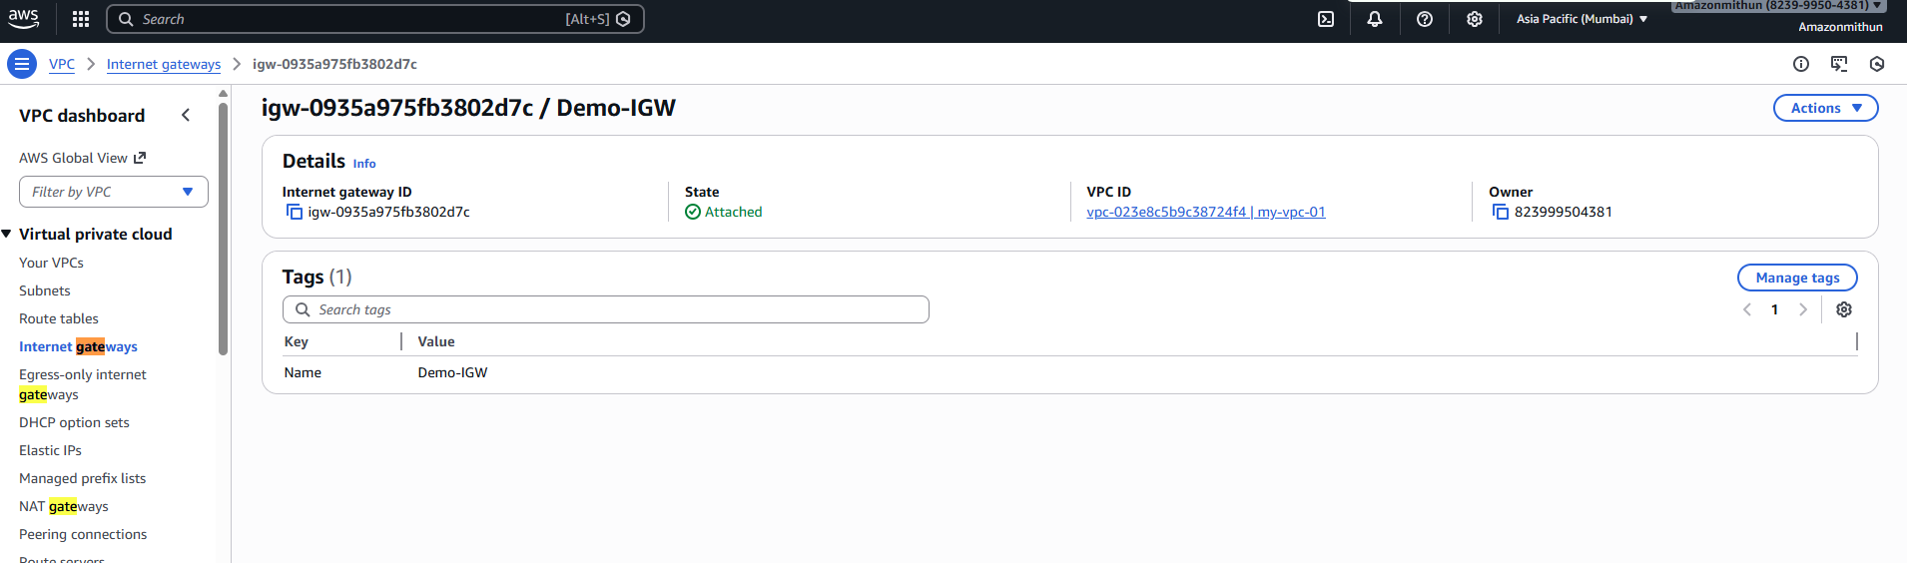
Created a Public and Private subnets with the different availability zones and added 10.0.1.0/24 for the public and 10.0.2.0/24 for the private in the CIDR block
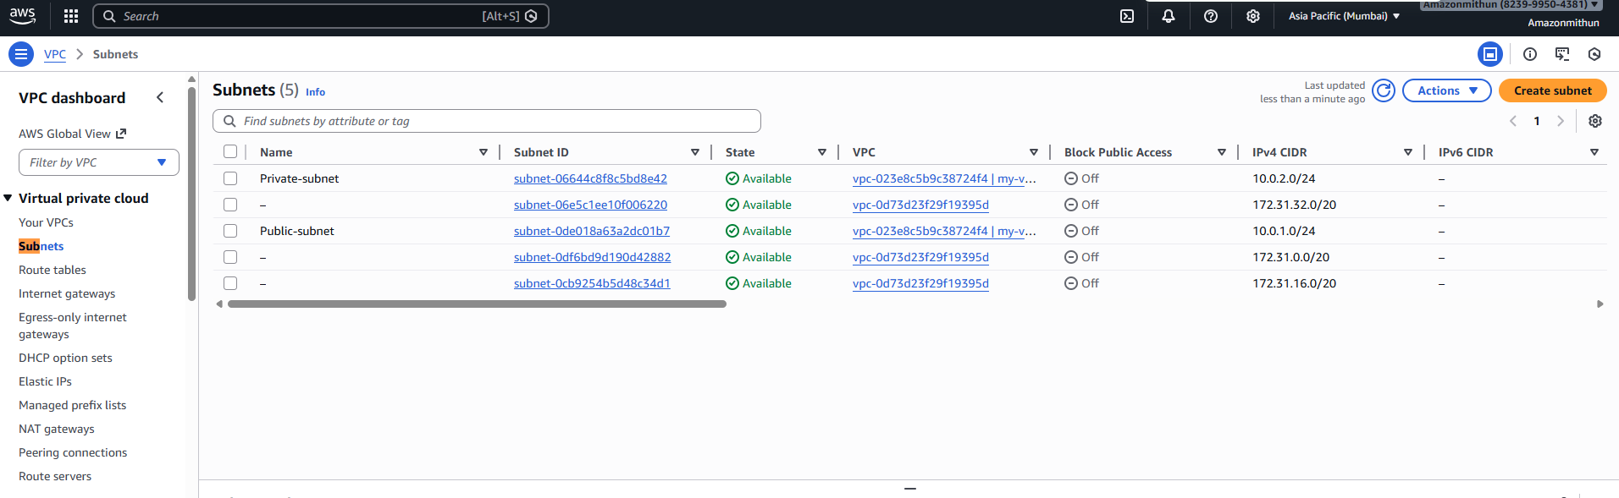
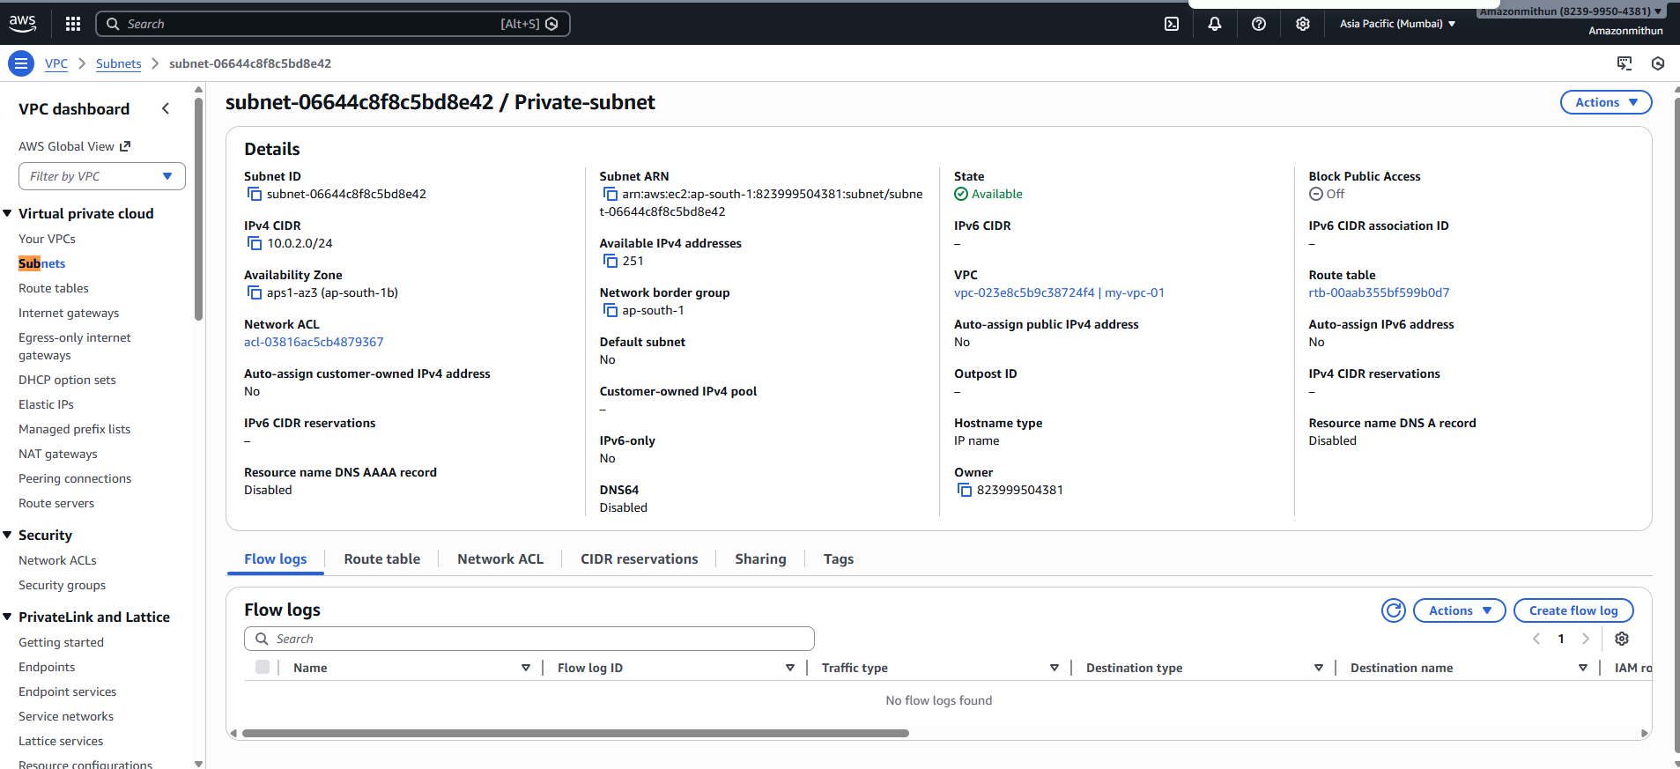
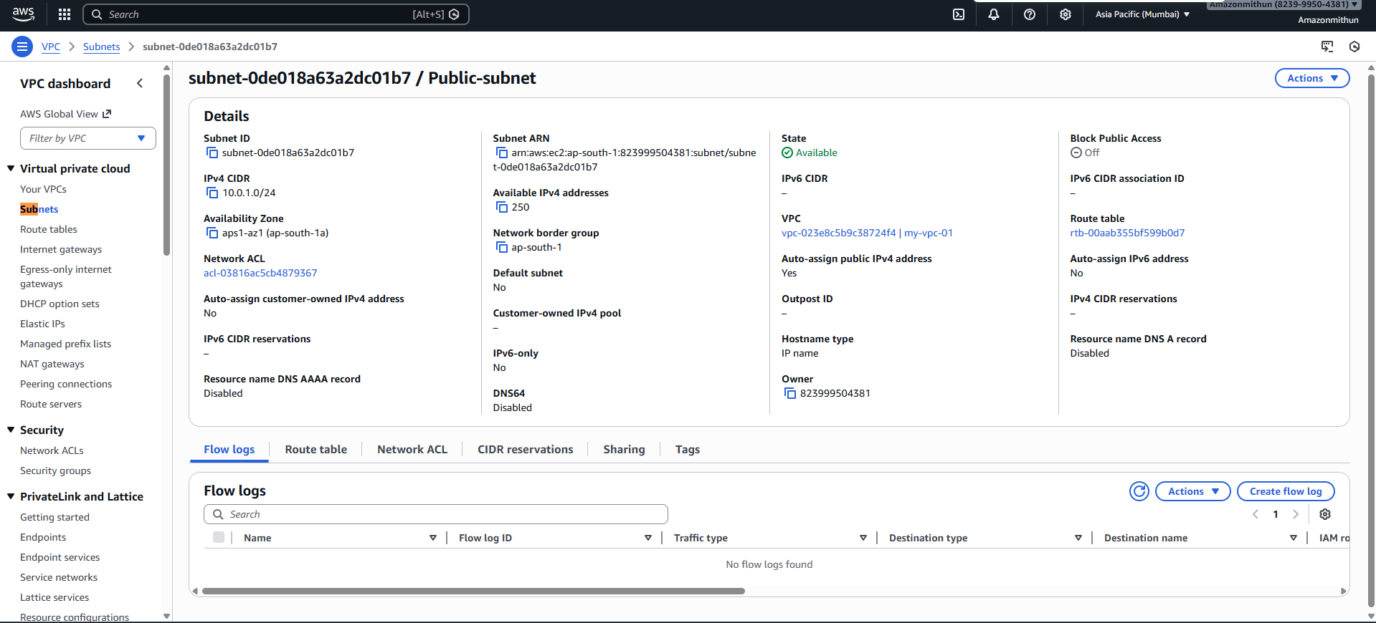
- Created a routing table named My-routetable-01 and attached the crated VPC (my-vpc-01)
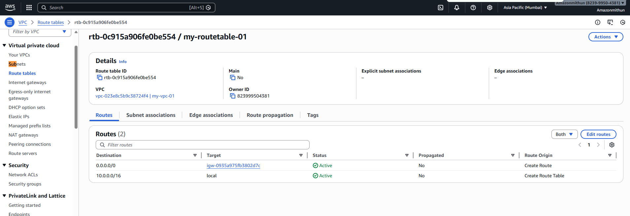
Also edited the route and added created Internet gateway to route table
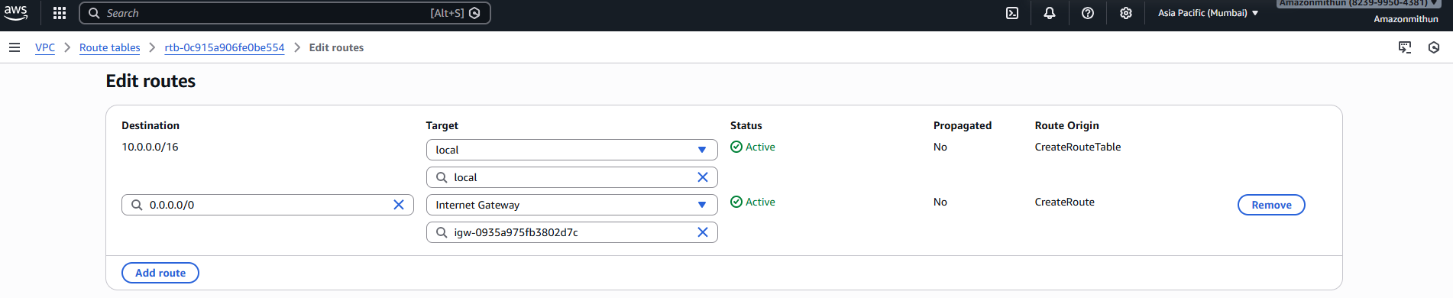
And within the Subnet association edited and enabled the auto assign IP settings to have the IPv4 address for the instance.
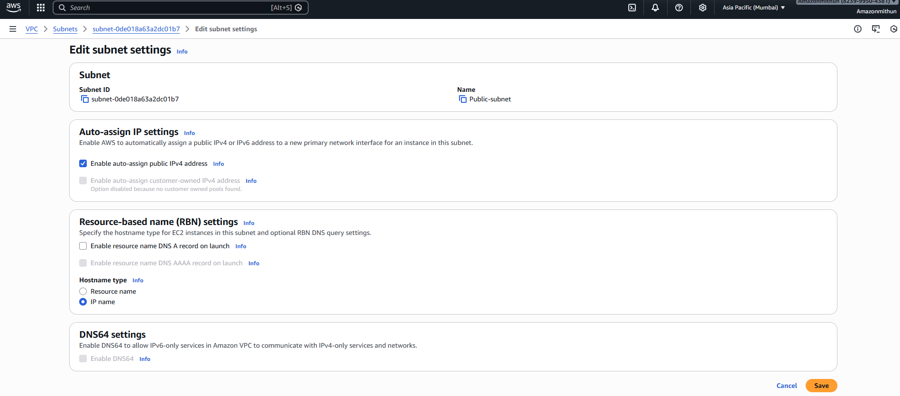
- Created the EC2 instance with the Ubuntu linux server and Windows Server and used EC2 instance connect.
- 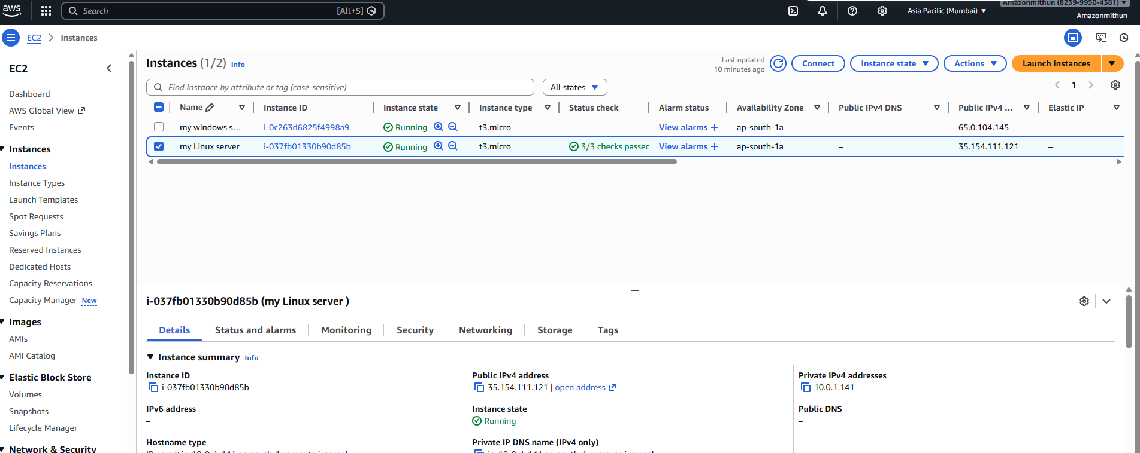
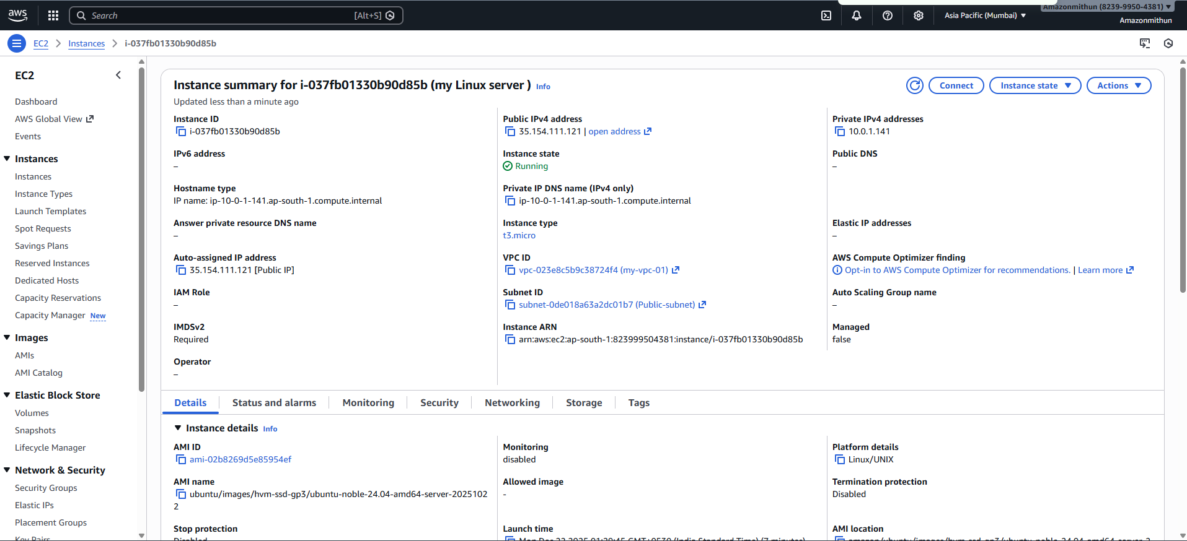
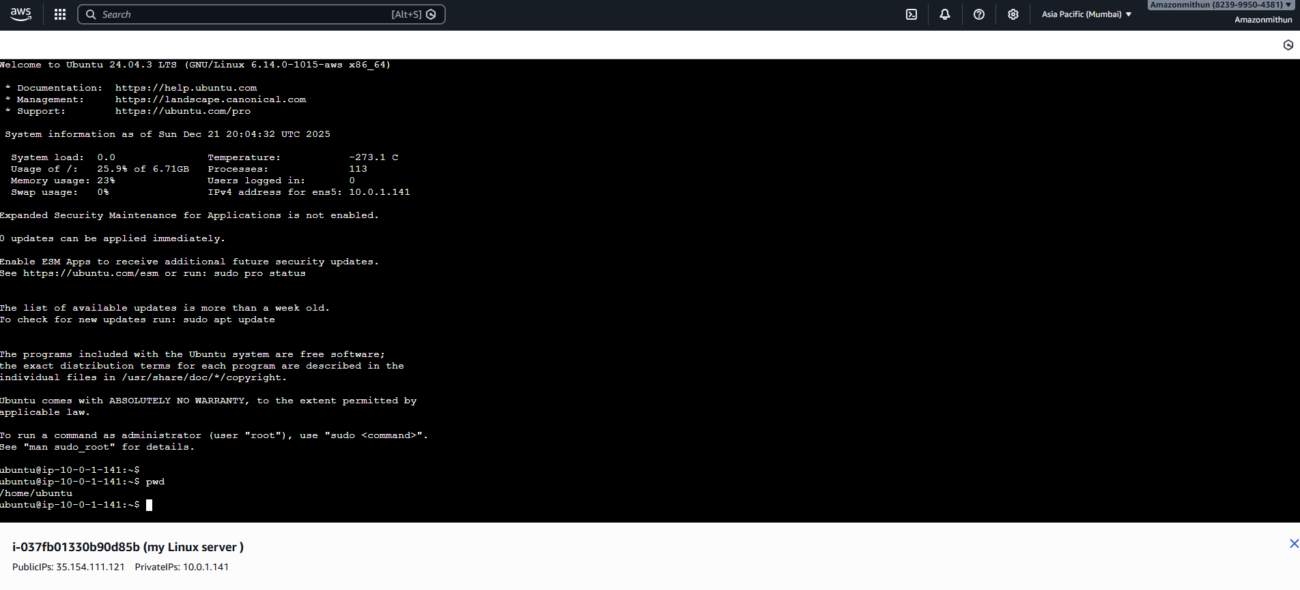
Checked the internet connectivity by pinging google.com
